FAIR HOUSING DAY

TRAINING TOPICS

FAIR HOUSING CASE
LAW UPDATE

UPDATES ON LANDLORD/TENANT ISSUES

SPONSORS:
Anderson Fair Housing Coalition
U.S. Dept. HUD
Community Development Block Grant Program – City of Anderson, Mayor Thomas J. Broderick, Jr.
Anderson Housing Authority
PathStone/Cinnaire
PNC Bank
Civil & Human Rights
City of Anderson
City of Muncie Human Rights
Old National Bank

REGISTRATION: FREE

REGISTRATION BEGINS AT
8:30 A.M.

FRIDAY, APRIL 8, 2022


IVY TECH -ANDERSON
815 EAST 60TH STREET
9:00 A.M. – 12:00 P.M.
PRESENTED BY:
PHILIP C. SHELTON, MSEd
DIRECTOR, FAIR HOUSING &
EQUAL OPPORTUNITY
INDIANAPOLIS, INDIANA

1:00 P.M. – 3:00 P.M.
JUDGE THOMAS CLEM &
OTHER LOCAL JUDGES

Limited Seating – Lunch Provided

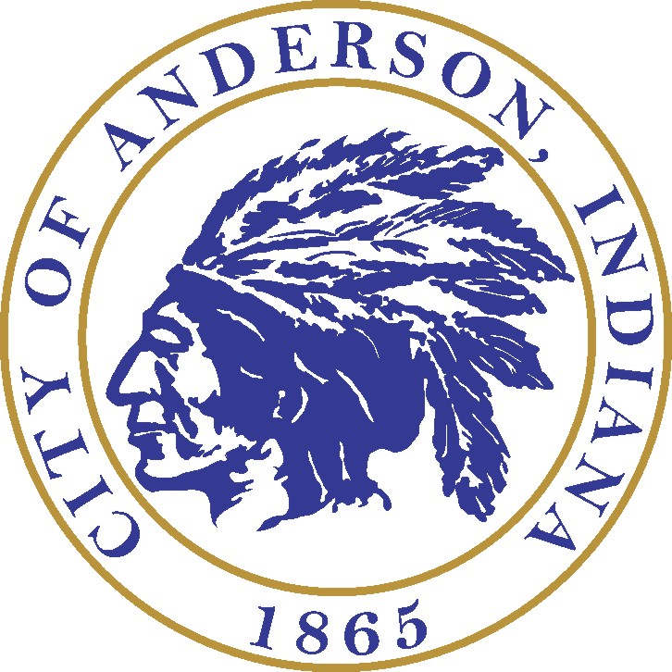
R.S.V.P. BY MARCH 25, 2022 AT:
765-648-6137 or lperry@cityofanderson.com

